**ABHISHEK SHARMA**

**R171218005**

**500067644**

**Section :B.Tech - CSE-Devops Subject :OOAD**

**CLASS TEST 2**

**Set -A**

Q.1 Define a Activity Diagram for Booking a Room in a hotel

When customer requests a room, the hotel employee looks for room availability, then he insert customer’s data and verifies if the provided credit card number has enough credit to pay the room: in this case the booking is confirmed and we wait customer arrival.

The Hotel information system allows customer to modify or cancel his/her reservation. If customer arrives he uses the room and then he pays, in case of no-show a penalty is accounted on his credit card and the booking is canceled.

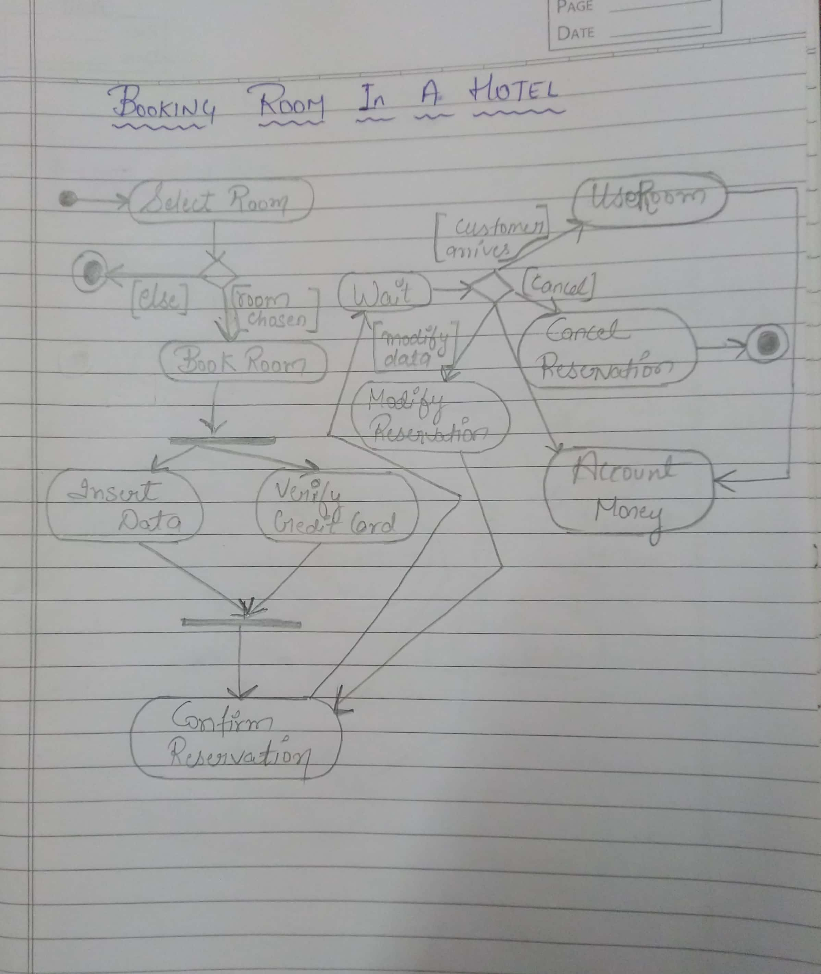

Q.2 Create a Activity Diagram for Product Management

When an order is received, check client data and availability in the inventory. If credit card data are enough to pay products, wait for payment and then send receipt. Once payment is registered in archive, client is notified of payment received.

If credit card data are ok, we verify if product is present in inventory, if not we have to fill order to buy it or, if the product is internally produced, we have start a production process, then the inventory is updated.

Once product is ready to be sent and payment is ok, we can send product to client.

